# Safety Warnings

THE MICRO:BIT IS AN EXPOSED BOARD, TO BE USED WITH CARE PLEASE RETAIN THIS INFORMATION FOR FUTURE REFERENCE. You can read the detailed document at - <http://microbit.org/guide/safety-advice/>

# General Safety Warnings

Using the BBC micro:bit is easy to use but is designed to have all the electrical parts on display. This does mean there's a small risk that the parts can be damaged and even overheat with a risk of injury but a little bit of care and caution will ensure you and your micro:bit will stay fit and healthy.



1. Always keep your BBC micro:bit in the anti-static bag when not in use. It's good practice for students to earth themselves before handling it.
2. Please handle your BBC micro:bit by its edges. This minimises the risk of damage through an electrostatic discharge.
3. Please use the battery pack and the USB lead provided to power your micro:bit. Do not use portable battery chargers or USB charging ports (often marked with a lightning bolt or 'SS'), to power your micro:bit. Using these may damage your micro:bit and stop it working properly.
4. Please avoid handling the BBC micro:bit circuit board while plugged into a power supply.
5. All peripherals (for example: USB cable, battery holder, sensors) used with your BBC micro:bit should comply with the relevant standards and should be marked accordingly.
6. Connecting your BBC micro:bit to any unapproved peripherals could damage your BBC micro:bit
7. Please do not attempt to keep using faulty micro:bits. If a school-issued micro:bit develops a fault, contact the vendor immediately.
8. The maximum current safely supplied to an external circuit using the 3V pin on the edge connector is 100mA. Please make sure this limit is not exceeded.
9. Please do not store or use your BBC micro:bit in extremely hot or cold environments.
10. Do not place any metal objects across the printed circuits on the board as this can cause a short circuit damaging your BBC micro:bit. This can cause risk of burn or fire.
11. Do not use your BBC micro:bit in water or with wet hands.
12. Do not leave your BBC micro:bit plugged into a computer or any other device unsupervised.
13. Please do not leave your BBC micro:bit within reach of children under 8 years of age.
14. Please operate your BBC micro:bit in a well ventilated room To remove the battery pack, pinch the connector with your fingers. Do not remove by pulling the wires.

# Battery Warnings



1. Do not try to charge normal (non-rechargeable) batteries
2. Please do not mix different types of batteries or mix new and used batteries.
3. Please use batteries of the same or equivalent type as those recommended.
4. Please insert batteries the correct way round (with the correct polarity).
5. Please remove spent batteries from the battery holder.
6. Do not short-circuit the battery supply terminals, for example by placing a metal object across the terminals.
7. Only use Zinc or Alkaline batteries with your BBC micro:bit.
8. Please do not use rechargeable batteries

# Pre-requisites

If you need assistance with the assembly of the micro:bit, Edge connector breakout board, mounting board and the breadboard please speak to on of the volunteers on duty.

To be able to perform this tutorial you will need the following components –

1. Parts required –
   1. 1 x BBC Micro:bit
   2. 1 x Mounting Plate
   3. 1 x Edge connector breakout board
   4. 1 x Bread board
   5. 1 x LED
   6. 1 x 2.2K Ohm Resistor
   7. 2 x Male – Female Dupont wires
   8. 2 x Male – Male Dupont wires
2. Assembly required –
   1. Bread board mounted on top of the mounting plate
   2. BBC Micro:bit inserted into the Edge Connector breakout board

# C:\Perf\Personal\Github\CoderDojo\Images\Hi_Res_BBC_Microbit.jpg

Before proceeding please check your setup and confirm that all the required parts are configured as demonstrated in the above picture.

# Learning Objectives

The objectives of this tutorial are to explore and learn the basic concepts of electricity, circuits, series circuits and elements that make up a series circuit.

Explore the following concepts through making –

1. What is a circuit
2. Current flowing through a circuit
3. What are passive and active components in a circuit
4. Connecting elements in a circuit in series

# Activity

Before we get started, let’s make sure that all the required components are configured as required –

# Step 1 - Explore Fundamentals

Discuss the following concepts with the learning facilitator

1. What is a circuit
2. Current flowing through a circuit
3. What are passive and active components in a circuit
4. Connecting elements in a circuit in series

## Self-Assessment

* I can explain what a circuit means
* I can explain the differences between active and passive components in circuits.
* I have the breadboard mounted onto the mounting plate.
* I have the Micro:bit plugged into the Edge connector breakout board.

# Step 2 - Build

Let’s now connect up the relevant components on our micro:bit.

1. Connect a Male – Female Dupont wire from the 3 Volt (3V) pin on the micro:bit to the positive rail of the breadboard
2. Connect a Male – Female Dupont wire from the positive rail of the breadboard to the 2.2K Ohm resistor
3. Connect one end of the LED to the 2.2K Ohm resistor
4. Connect a Male – Female Dupoint wire to the other end of the LED and to the 0 Volt ( 0V) or ground pin on the micro:bit.

## Self-Assessment

* I understand each of the components in the circuit i.e. LED, resistor, Male – Female Dupont wires
* I have each of the elements in the circuit wired up using the breadboard
* I have checked the connections on the circuit and have not powered it on.

This now completes your circuit.

PLEASE DO NOT POWER ON YOUR MICR:BIT UNLESS YOU HAVE HAD YOUR CIRCUIT VALIDATED BY A FACILITATOR.

# Step 3 – Validate

Please call a facilitator to check your circuit before you power it on. It is important that you get a learning facilitator to check the connections on your circuit before powering it on.

Incorrect connections might result in a dead (bricked, burnt, short-circuited, etc.) Micro:bit requiring you to purchase another Micro:bit for $30 AUD.

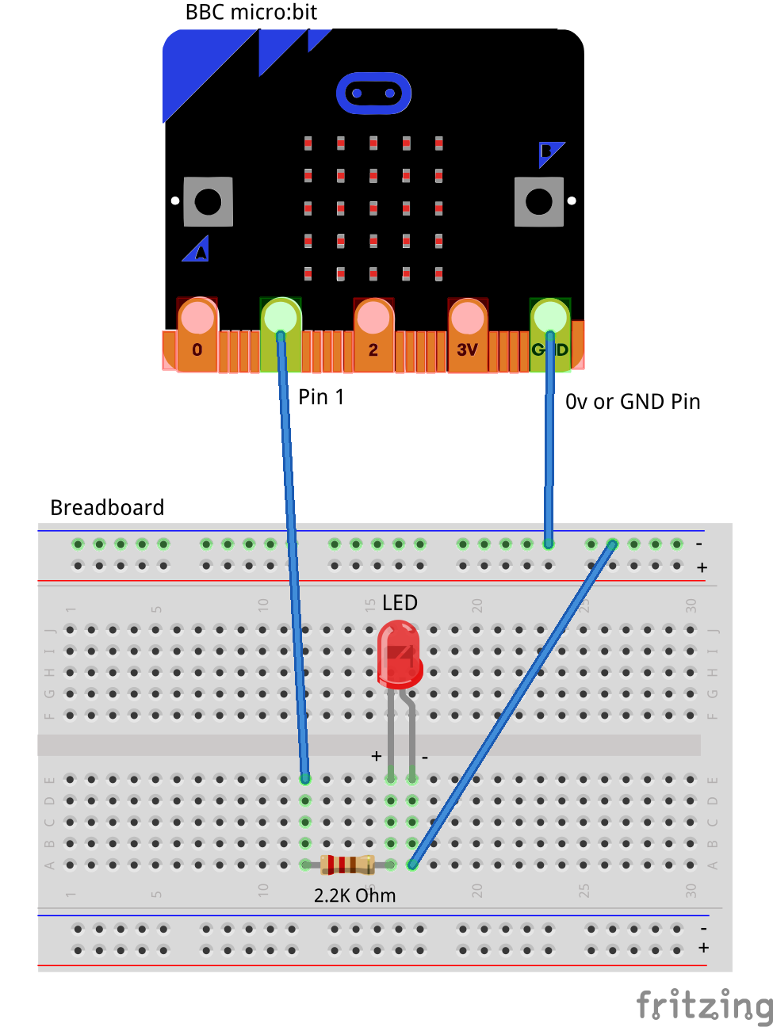

# Step 4 – Power On

Awesome, you are almost at the point where you can power on your circuit and watch the magic un-fold. Please call a facilitator to check your circuit before you power it on. It is important that you get a learning facilitator to check the connections on your circuit before powering it on.

Once the learning facilitator has verified your circuit you should now proceed and power on the Micro:bit. If you have not had your learning facilitator verify the circuit PLEASE GO BACK To step 3 and have one of the learning facilitators verify your connections.

Powering on the Micro:bit requires that you connect the USB power cord for your Micro:bit (plugged into the Micro:bit board) into your laptop.

Incorrect connections might result in a dead (bricked, burnt, short-circuited, etc.) Micro:bit requiring you to purchase another Micro:bit for $30 AUD.

## Self-Assessment

* I am able to wire a series circuit
* I understand the flow of current through a series circuit
* I understand the difference between 3 Volt (3V) and Ground (0 Volt of 0V)

# Challenges

Well done for completing the Series Circuit tutorial. There’s a lot of ground we have covered in this tutorial so please feel free to make notes, come back to the tutorial at some point down the line and ask your learning facilitator any questions or doubts you might have on the concepts covered to far.

For those who want to stretch it a bit further -

1. What happens if you add another LED or more than a couple of LED’s in series with the first one?
2. What happens if you add a lower value resistor? How is the flow of current impacted?
3. What happens if you add a higher value resistor? How is the flow of current impacted?